Relationship between Lactiplantibacillus plantarum KY1032 and Lactibacillus curvatus HY7601
Not All Beneficial Bacteria are Beneficial Together: The complex dynamics of two probiotics, Lactiplantibacillus plantarum KY1032 and Lactibacillus curvatus HY7601, modeled in vivo (Gallus gallus)
Chloe J. McGovern¹, Elad Tako¹
¹Department of Food Science, Cornell University, Ithaca, NY 14850

Target Journals
Cell Host and Microbiome
Gut Microbes
Microbiome
Frontiers in Microbiome
NPJ Biofilms and Microbiome
Abstract

Key words: probiotics, gut microbiome, intestinal functionality, Gallus gallus, in ovo

Introduction
Complex foods multiple cultures

Probiotics not one size fits all

Symbiotic relationships

Beneficial outcomes

L plantarum

L curvatus

Objective

Materials and Methods
The methods below closely follow those previously reported in CITY LPHY PAPER. Below are brief descriptions of the methods used in the study.
- Preparation of Culture and Intra-amniotic Injection Solutions
A powdered probiotic product was received from hy Co., Ltd (Seoul, South Korea). A half gram of L. plantarum KY1032 and L. curvatus HY7601 (MIX) powder was added to MRS broth (BD Difco Lactobacilli MRS Broth, Franklin Lakes, NJ, USA) and incubated at 37 °C for 48 hours. The ratio of the two bacteria was 1:1. Lawn plates were streaked to isolate bacteria from the whole supplement on MRS plates and incubated for 48 hours at 37 °C. After incubation, a slurry of probiotic isolates in MRS broth was made to a total volume of 50 mL. The slurry was centrifuged (Allega X-30R Centrifuge, Beckman Coulter, Brea, CA) down at 2100 x g for 15 minutes. The supernatant was poured off, and the bacterial pellets were diluted in sterile saline (0.85% NaCl) (VWR Sodium Chloride, Randor, PA, USA) for a final three doses targeting 10⁵, 10⁶, and 10⁷ CFU per mL. To confirm estimated probiotic doses, each dose was serial diluted and plated on MRS to confirm the injected CFU/mL in the in ovo study outlined below.
- In ovo (intra-amniotic administration) Study Design
The in ovo study outlined below follows the protocol outlines in IACUC protocol #2020-0077. Broiler eggs were received from Aviagen (308 Ross, Huntsville, AL). Eggs were immediately put into the incubator (Model I-14, NatureForm Hatchery Systems, Jacksonville, FL, USA) at the Cornell University Animal Science Poultry Farm (Ithaca, NY, USA) under optimal conditions of 37 °C and 30 °C wet bulb temperature. Eggs were candled on Day 9 and Day 12 for viability. Non-viable eggs were removed as detected.
Embryonic age 17 days was the day for the intra-amniotic injection. Viable eggs were weighed and sorted by weight and evenly distributed by weight into the treatment groups. Eggs were stored by assigned treatment group in the incubator until injection. For each injection group, eggs were candled again to identify appropriate injection site, marked, and pierced with single-use 25-gauge needles (BD, Becton, Dickinson and Company, Franklin Lakes, NJ, USA). This was followed by injected 1 mL of solution, sterilized, and the injection site was sealed. The injection groups were as followed; sterile MilliQ water (18 MΩ H₂O), sterile 0.8% saline, L. plantatrum KY1032 and L. curvatus HY7601 (MIX in the results) at 4.0 x 10⁵ CFU / mL (MIX Dose 1), 2.75 x 10⁶ CFU / mL (MIX Dose 2), and 3.2 x 10⁷ CFU / mL (MIX Dose 3). Additionally, there was a non-injection control group that after weighing and distribution was put into the hatcher (Model NMC-2000, NatureForm Hatchery Systems). At the end of injection day, all 6 groups had 26 eggs in their respective hatching baskets.
- Euthanasia and Tissue Collection
Birds were euthanized via carbon dioxide exposure. The yolk sac, duodenum, colon, ceca, liver, and pectoral muscles were collected after euthanasia and stored in liquid nitrogen during collection. Duodenum tissue samples were also collected for histology and stored in formaldehyde.
- Histological Analysis of the Duodenum
Cross sections of duodenal tissue were taken for histological analysis to determine the morphometric effect the probiotics had on tissue structure. Briefly, 5 µm thick cross-sections were cut from each parafilm embedded tissue cassette, placed on slides, deparaffinized in xylene, rehydrated in a graded alcohol series, and stained with Periodic Acid–Schiff and Alcian Blue. Slides were examined under an Olympus BX43 manual system microscope fitted with a DP22 2.8-megapixel digital camera (Olympus Life Science Solutions, Tokyo, Japan) using cellSens Imaging Software Version 3.1 (Olympus Life Science Solutions).
Final morphometric measurements were villi width (done at the base, the middle, and the top of the villi), villi height, crypt depth, and goblet cell count (Figure 1). Ten villi measurements were taken on duodenum cross section; seven cross sections were measured per group. Goblet cells were counted on the measured ten villi. Villus height was defined as the vertical distance from the villus tip to the villus–crypt junction or invagination. Goblet cells were distinguished based on their characteristic circular shape and purple to deep blue color, which corresponds to goblet cells.
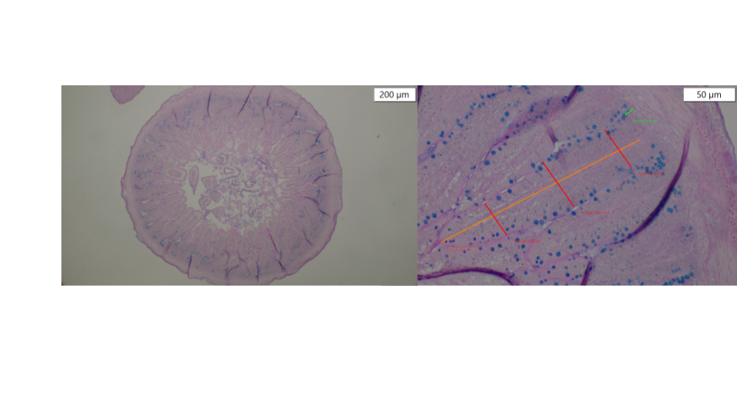
Figure 1 Histology Methodology. Duodenal cross sections were viewed at 4x objective (left image) and zoomed in to 20x objective (right) for histomorphometric analysis. On right image, orange line demonstrates how length was measured the red highlights the three width points taken, and the green represents the crypt depth measured. Blue dots along the edge of the villi and crypt are goblet cells visible with Alcain Blue staining.
These were used to calculate villi surface area shown below, where VW stands for villi width and VH abbreviates for villi height, with the assumption that villi are cylinders. Villi height and crypt depth were also used to calculate height-to-crypt depth ratio (VH:CD).
$$Villi Surface Area=2π\left(\frac{VW}{2}\right)\left(VH\right)+π{\left(\frac{VW}{2}\right)}^{2}$$

- RNA Extraction and cDNA Conversion for Duodenum, Liver, Colon, and Pectoral Muscle
Briefly, 80 mg of tissue (either duodenum, liver, colon, and pectoral muscle) were added to 1 mL of lysing buffer (QIAzol Lysis Reagent, Qiagen, Venlo, Netherlands) and homogenized (Pro Series, Bullet Blender, Next Advanced, Troy, NY). Chloroform was added to the homogenied tissue, shaken and set aside at room temperature before being centrifuged at 12,000 x g for 15 minutes at 4 °C (Allega X-30R Centrifuge, Beckman Coulter, Brea, CA). The aqueous phased was pipetted into a new tube where equal volume isopropanol was added additionally. The new tube was vortexed, incubated on ice for 10 minutes, and 12,000 x g for 10 minutes at 4 °C. A small pellet could be seen at the bottom after centrifuging, where a “washing” step took place twice with 75% ethanol and centrifugation. Residual ethanol was pipetted out the tube, and the pellet was left to dry until it turned clear and hydrated in nuclease free water. RNA was nano-dropped (NanoDrop 2000C Spectrophotometer, Thermo Scientific, Waltham, MA) for concentration and standardized to 2 µg / mL. Standardized RNA went through cDNA conversion with the High-Capacity cDNA Reverse Transcription Kit (Applied Biosystems, Waltham, MA). After reagents were added, the mixture went through the thermal cycler (MJ Mini, Personal Thermal Cycler, BioRad, Hercules, CA) using the cDNA program.
- Tissue Specific Gene Expression with RT-PCR
Primers and their respective tissue applications can be seen in Table 1 and were ordered through NCBI.
Table 1 PCR Primers
Gene | Accession Number | Primer Sequences (5’→3’) | Primer Size (bp) | Tissue
GAPDH | NM_204305.2 | F: TCGGAGTCAACGGATTTGGC  R: TTCCCGTTCTCAGCCTTGAC | 20  20 | All
MUC2 | XM_040673065.2 | F: CTCTGGCTGGCTCTTTCCAA  R: AATGGTTGTTCCCCCAGGTG | 20  20 | Duodenum, Colon
OCLN | NM_205128.1 | F: GTCTGTGGGTTCCTCATCGT  R: GTTCTTCACCCACTCCTCCA | 20  20 | Duodenum, Colon
TNFα | NM_204267.2 | F: GACAGCCTATGCCAACAAGTA  R: TTACAGGAAGGGCAACTCATC | 21  21 | Duodenum, Colon
PRAAK1 | NM_001039603.2 | F: CTGTCACAGGCACATGGTAGT  R: TGGGCCTGCATATAACCTTCC | 21  21 | Liver
PRAAK2 | NM_001039605.2 | F: GGCAAAGTCAAGGTTGGCG  R: GAAGAAGTCTGTTGGCGTGC | 19  20 | Liver
MyoG | NM_204184.2 | F: CATCCTGCAGCCCTGAGT  R: GAGGAGAGCGAGTGGAGGTT | 18  20 | Pectoral
MyoD | NM_204214.3 | F: AGCTCTCGCAGGAGAAACAG  R: GGAAATCCTCTCCACAATGC | 20  20 | Pectoral
mTOR | XM_417614.8 | F: AAAGCAGCTCTTCCACCAAA  R: TGGCTCGTGCCAACATACTA | 20  20 | Pectoral
MyHC1 | NM_204587.2 | F: ACGGGCCTGATCAACCAAA  R: GGCCTTCTTGGCTTTCTCCT | 19  20 | Pectoral
MyHC2α | NM_204228.3 | F: GGGAGACCTGAATGAAATGGAG  R: CTTCCTGTGACCTGAGAGCATC | 22  22 | Pectoral
The qRT-PCR analysis used a Bio-Rad C1000 touch thermocycler and Bio-Rad iTaq™ Universal SYBR® Green Supermix (Bio-Rad Laboratories Inc., Waltham, MA). The final qPCR volume was 10.0 μL where 5.0 μL was SYBR Green (PerfeCTa SYBR Green FastMix, Quantabio, Beverly, Massachussetts) 2.0 μL of cDNA diluted 1:10, 0.5 μL of each primer (forward and reverse), and 2.0 μL of nuclease free water. Thermocycling protocol followed the kit manual and analysis of melt curved, Ct values, and GAPDH for the housekeeping gene were the same as used in CITE LPHY PAPER.
- Antimicrobial Genome Mining of L. curvatus HY7601
The genome of L. curvatus HY7601 was analyzed to identify genes or regions associated with antimicrobial and bacteriocin activity. Genome mining was initiated by uploading the genome (.fasta file) to BAGEL4 run in Ubuntu on Windows (van Heel et al., 2018). The BAGEL4 output included Areas of Interest (AOIs), HMMER Pfam domain annotations, and BLAST-based functional predictions. To validate and expand upon the predicted antimicrobial peptides, the protein sequence file (.faa) were queried against the SwissProt database using NCBI BLASTp remotely. BLAST parameters were set to a maximum of 5 hits per sequence, an E-value threshold of 1e-5, and a tab-delimited file (.tsv). Predicted clusters were also analyzed with antiSMASH to screen for RiPP-like secondary metabolite clusters (Blin et al., 2023). To refine protein domain characterization, HMMER searches were run against the Pfam-A database identifying motifs within AOIs associated with antimicrobial activity (Mistry et al., 2021).
- 16S RNA Sequencing of Ceca Microbial Community[CM1.1]
Ceca samples were sequenced for microbial community diversity. Samples were stored at -80 °C until being shipped in dry ice to The Arizona Genomic Institute (Arizona State University, Tempe, AZ) for RNA sequencing. Briefly, DNA samples from the ceca were extracted with DNeasy PowerSoil (Quiagen, Hilden, Germany) with a modified 50 uL elution, then diluted to 0.2-0.4 ng uL-1 to prepare for sequencing. PacBio 16S rRNA long-read sequencing was done to sequence the full 16S genome. Genes were amplified with 27F to 1492R Kinnex primer set. Amplified products were pooled and underwent multiple SMRTbell cleanup steps between adapter addition, array formation, and nuclease treatment. The final SMRTbell library underwent additional cleanup using 3.1x diluted AMPure PB beads was quantified with Qubit, and assessed with Femto Pulse prior to equimolar pooling of barcoded libraries.
Sequencing was performed on PacBio Sequel II using circular consensus sequencing HiFi chemistry and yielded an average ~230,000 reads per sample, with a mean read length of XXX. Quality control of raw reads included FastCQ (v.011.9) (CITE WEBSITE). ADD BIOINFORMATICS INFO HERE
Both ceca from two birds from each treatment group were paired to create one sample for sequencing. Five total pairs of ceca were analyzed for all treatment groups except the water control, which had three due to the hatchability. Associated genomes to this project are submitted to the ENA under project number ####.
- Targeted Metabolomics with Short Chain Fatty Acids and Cecal Biomarkers
Extracted cecal DNA from the RNA sequencing step was used in PCR for two AMR genes (bacA and bcrA). They were extracted on a QuantStudio3 Thermal Cycler (Applied Biosystems, Foster City, CA, USA). Primer and probe sequence … ???
For SCFA analysis, approximately 0.2 g of cecal content was vortexed with 4 mL of 18Ω water for 10 minutes. If samples were less than 0.2 g, extraction followed a 20× dilution scaled to sample mass. 1 mL of the homogenized slurry was pipetted into a 2 mL microcentrifuge tube and then centrifuged at 10000 rpm for 10 minutes. The supernatant was syringe-filtered through a 0.22 µm PTFE filter into a 2 mL autosampler vial for HPLC analysis. Samples were analyzed on an Agilent 1260 Infinity II HPLC (Agilent Technologies, Santa Clara, CA, USA) using a 65 °C Aminex HPX-87H (300 × 7.8 mm) column (Bio-Rad Laboratories, Hercules, CA, USA) with an isocratic 0.0025M H2SO4 mobile phase at 0.6 mL/min, and DAD wavelength 210 nm.
- Dose Response Effect Model

- Statistics
Data analysis was done in RStudio (Posit PBC, Boston, MA, USA) and is organized in GitHub (GitHub, Inc., San Francisco, CA, USA) which can be accessed by emailing the corresponding author. Genome availability is limited due to the proprietary nature of hy Co., Ltd. private collection, but questions regarding genome analysis can be directed to the corresponding author. Appropriate parametric or non-parametric statistical tests (ANOVA-Tukey or Kruskal Wallis-Dunn with Holm p-value adjustments) were conducted depending on if test assumptions were met. A linear mixed model was used for histological data analysis. Statistics were considered significant if p < 0.05.
Results
The results shown below are the key findings in the in ovo model for two lactic acid bacteria, L. plantarum KY1032 and L. curvatus HY7601, in a dose response analysis. In SUP TABLE 1, the controls of water and saline had minimal and no hatchability. The injection material was stored frozen until the morning of injection day (D17). All other groups were affected by injection material. The conclusion about the reduced hatchability for water is that it was too cold for the embryos as it was the first injection of the day and shocked the egg. Additionally, for saline, the assumption is that there were ice crystals changing the salinity of the injection material, resulting in too high osmolarity with the temperature difference between the cold solution and warm embryos resulting in no viable eggs. Other hatch biomarkers such as body weight and ceca weight saw no significant difference between (p < 0.05) (SUP FIG 1 ad FIG 2).
Histology is a tool that can allow visual investigation of the treatments effect on tissue structure. When looking at duodenal tissue cross sections for histology, there are a few measurements that are of most importance in translating to functional outcomes. Those are villi surface area, VH to CD ratio, and the goblet cell count, Figure 2. Preliminary measurements to achieve the values seen below can be seen in SUP FIG 3. There is a significant increase in villi surface area between the no injection group and all the injected groups. Specifically, MIX Dose 1 has the greatest average surface area and was significantly different from MIX Dose 2 and 3. Additionally, MIX Dose 1 and 3 were significantly different from the water control injection group. This is important because the villi surface area is associated with better nutrient sensing and absorbing. Therefore, the greater the surface area the better functionality of the villi associated. The VH:CD ratio is important to indicate intestinal cell regeneration for the brush border membrane (BBM). There is a significant decrease between MIX treatments and both the no injection and water control. Even though the ratio decreases for the MIX treatment groups, it is not associated with negative results. Simply put, the relationship between the crypt and the cellular turnover is steady enough for the system. Lastly, a key biomarker that can be quantified with histology is goblet cell count. Goblet cells are responsible for mucin production which creates a physical protective layer for the BBM. The results for goblet cell count show that as probiotic dose increases, the number of goblet cells increase significantly.
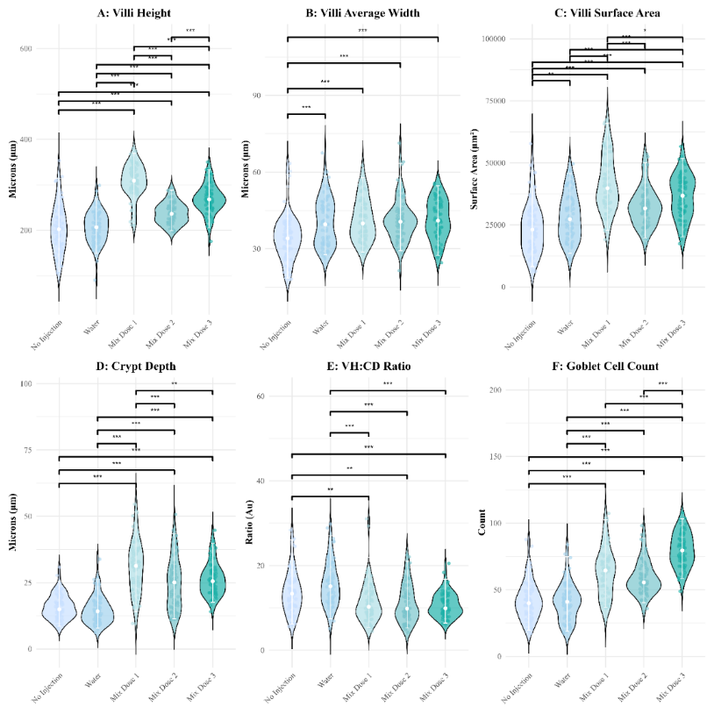
Figure 2 Histology Data from Duodenal Loop Samples. MIX Dose 1 is 4.0 x 10⁵ CFU/mL (n=8), MIX Dose 2 is 2.75 x 10⁶ CFU/mL (n=8), and MIX Dose 3 is 3.2 x 10⁷ CFU/mL. 7 biological replicates (tissue samples) were analyzed, where 10 villi were randomly selected around the tissue and measured for villi height and width, crypt depth, and goblet cell count on the sample villi. VH:CD stands for the villi height to crypt depth ratio. A linear mixed model was used to determine significant differences.
Gene expression of specific biomarkers in several tissues was used for indicators of effect of probiotic treatment. In the duodenum, MUC2, OCLN, and TNF-α were explored to determine if the amount of probiotic had a relationship to the expression level, Figure 3. Across all three genes, there is a visual trend that there is a decrease in expression level at MIX Dose 3, significantly for OCLN and TNF-α (p < 0.05). Opposite, MIX Dose 2 has the highest average expression level for all three genes, with MUC2 and TNF-α being significantly higher than the no injection group (p > 0.05).
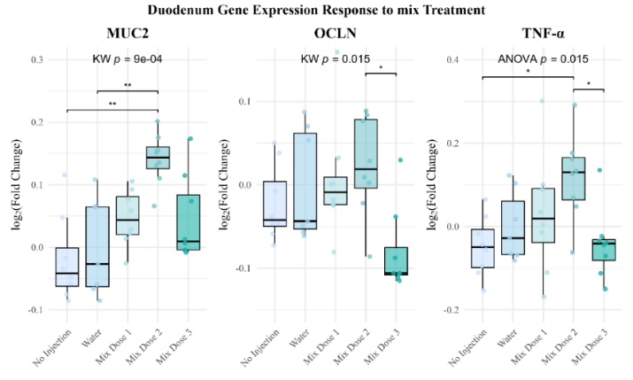
Figure 3 Duodenal tissue PCR results. MIX Dose 1 is 4.0 x 10⁵ CFU/mL (n=8), MIX Dose 2 is 2.75 x 10⁶ CFU/mL (n=8), and MIX Dose 3 is 3.2 x 10⁷ CFU/mL. MUC2 is Mucin 2 protein, OCLN is Occludin, and TNF-α is Tumor Necrosis Factor-alpha. Appropriate statistical analysis and corresponding p-value are labeled on each figure.
Similarly to the duodenum, MUC2, OCLN, and TNF-α were investigated in the colon, Figure 4 with different trends. For MUC2, there is a significant decrease in expression for MIX Dose 3 compared to MIX Dose 2 and the no injection group. OCLN loosely sees an increase in expression across doses with significant differences (p > 0.05) between no injection and water, MIX Dose 1, and MIX Dose 3. With a significant difference in expression between MIX Dose 2 and 3 (p > 0.05). Inversely, TNF-α shows an opposite trend with gene expression decreasing as probiotic dose increases.
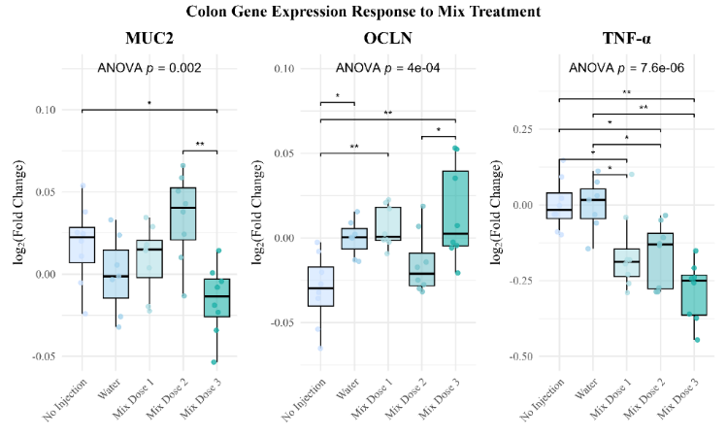
Figure 4 Colon tissue PCR results. MIX Dose 1 is 4.0 x 10⁵ CFU/mL (n=8), MIX Dose 2 is 2.75 x 10⁶ CFU/mL (n=8), and MIX Dose 3 is 3.2 x 10⁷ CFU/mL. MUC2 is Mucin 2 protein, OCLN is Occludin, and TNF-α is Tumor Necrosis Factor-alpha. Appropriate statistical analysis and corresponding p-value are labeled on each figure.
In the liver there is an apparent positive dose response trend, where an increase in probiotic dosage related to the highest average expression of AMPK pathway indicators PRKAA1 and PRKAA2, as seen in Figure 5. As probiotic dosage increases, the idea is that more SCFAs are being produced as well. The SCFAs directly activate the AMPK pathway correlating to a higher expression level.
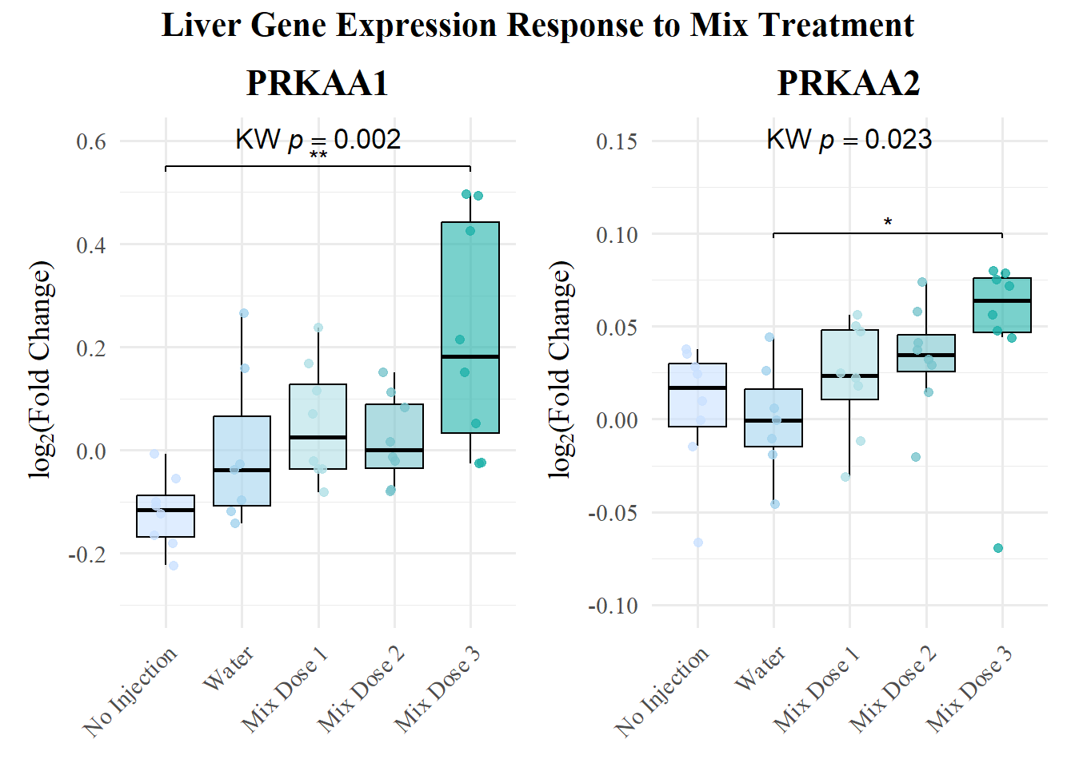
Figure 5 Liver tissue PCR results. MIX Dose 1 is 4.0 x 10⁵ CFU/mL (n=8), MIX Dose 2 is 2.75 x 10⁶ CFU/mL (n=8), and MIX Dose 3 is 3.2 x 10⁷ CFU/mL. PRKAA1 and PRKAA2 are Protein Kinase AMP-Activated Catalytic Subunit Alpha 1 and Alpha 2, respectively. Appropriate statistical analysis and corresponding p-value are labeled on each figure.

NO IDEA ABOUT MUSCLE
GET RID OF MYOD ??
BLAH BLAH BLAH
Figure 6
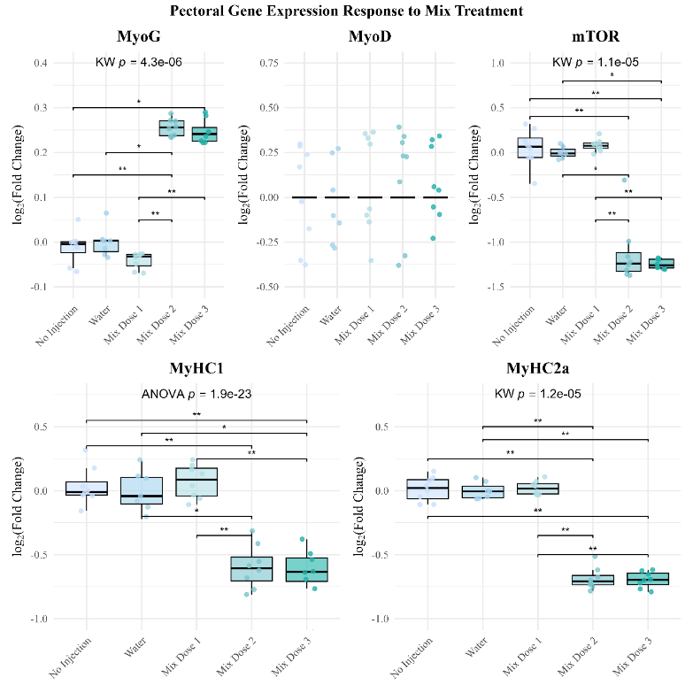
Figure 6 Pectoral muscle PCR results. MIX Dose 1 is 4.0 x 10⁵ CFU/mL (n=8), MIX Dose 2 is 2.75 x 10⁶ CFU/mL (n=8), and MIX Dose 3 is 3.2 x 10⁷ CFU/mL. MyoG is myogenin, MyoD is myogenic differentiation 1, mTOR is mammalian target of rapamycin, MyHC1 and MyHC2a are myosin heavy chain 1 and 2a, respectively. Appropriate statistical analysis and corresponding p-value are labeled on each figure.

DON’T WRITE BACTERIOCIN SECTION YET

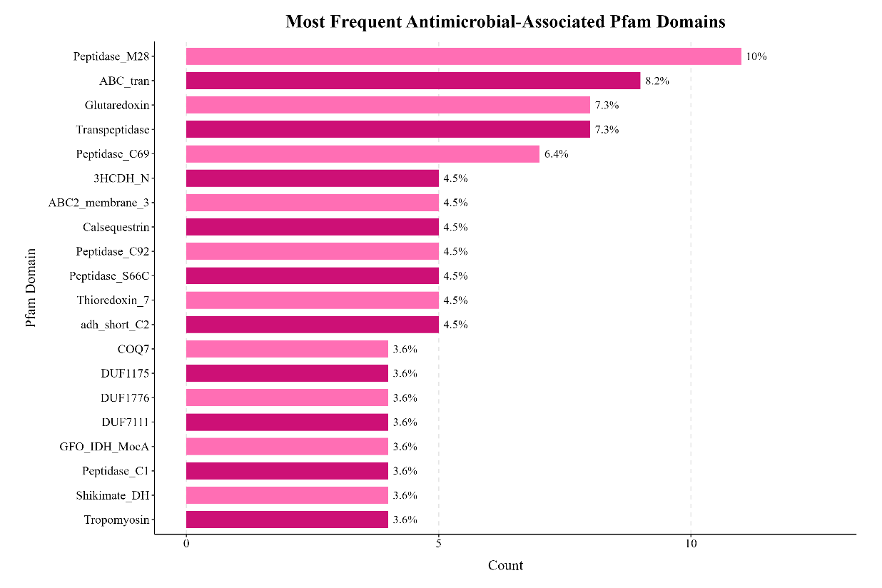
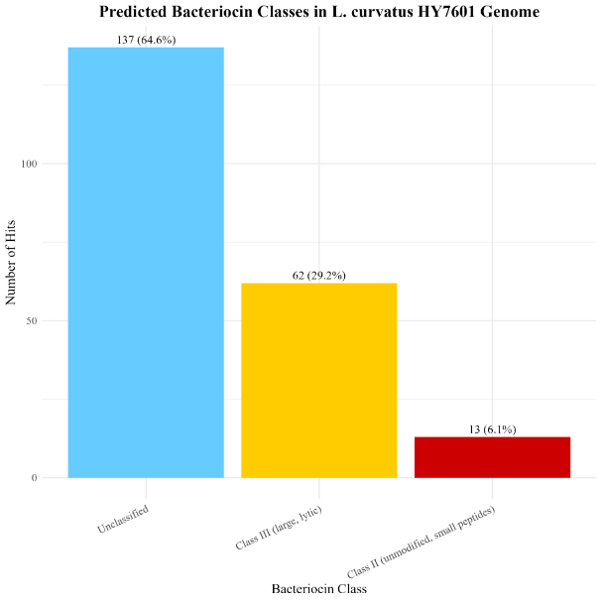
Figure 7 Bacteriocin classes identified in L. curvatus HY7601 genome.

Discussion

Conclusion

Acknowledgement
The authors would like to thank hy Co., Ltd for supplying the probiotic cultures for this experiment, specifically Il-Dong Choi and his team. Thank you to the Tako Research Lab for support during tissue collection day. Vicky Simon, Manager of the Human Nutritional Chemistry Service Laboratory, Cornell University. Thank you to Dr. Lee Voth Gaeddert from Arizona State University for aiding in the sequencing.
References
Blin, K., Shaw, S., Augustijn, H. E., Reitz, Z. L., Biermann, F., Alanjary, M., Fetter, A., Terlouw, B. R., Metcalf, W. W., Helfrich, E. J. N., van Wezel, G. P., Medema, M. H., & Weber, T. (2023). antiSMASH 7.0: New and improved predictions for detection, regulation, chemical structures and visualisation. Nucleic Acids Research, 51(W1), W46–W50. https://doi.org/10.1093/nar/gkad344
Mistry, J., Chuguransky, S., Williams, L., Qureshi, M., Salazar, G. A., Sonnhammer, E. L. L., Tosatto, S. C. E., Paladin, L., Raj, S., Richardson, L. J., Finn, R. D., & Bateman, A. (2021). Pfam: The protein families database in 2021. Nucleic Acids Research, 49(D1), D412–D419. https://doi.org/10.1093/nar/gkaa913
van Heel, A. J., de Jong, A., Song, C., Viel, J. H., Kok, J., & Kuipers, O. P. (2018). BAGEL4: A user-friendly web server to thoroughly mine RiPPs and bacteriocins. Nucleic Acids Research, 46(W1), W278–W281. https://doi.org/10.1093/nar/gky383

Supplemental Material
Supplemental Table 1 Hatchability Data
Treatment Group | Hatch Number (out of 26) | Percentage (%)
No Injection | 23 | 88.46
Sterile Water (18 MΩ H₂O) | 7 | 26.92
Sterile 0.85% Saline Water | 0 | 0
MIX Dose 1 | 24 | 92.31
MIX Dose 2 | 26 | 100
MIX Dose 3 | 24 | 92.31

Supplemental Figure 1 Body Weight at Hatch
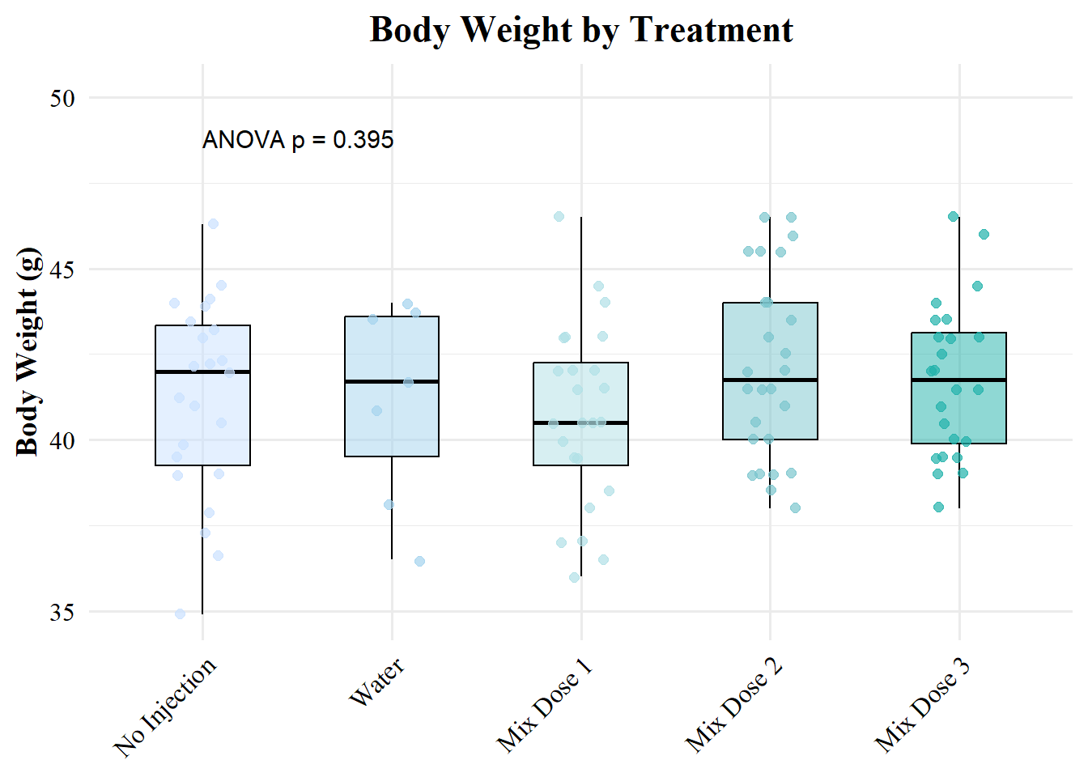
Supplemental Figure 2 Ceca Weight at Hatch
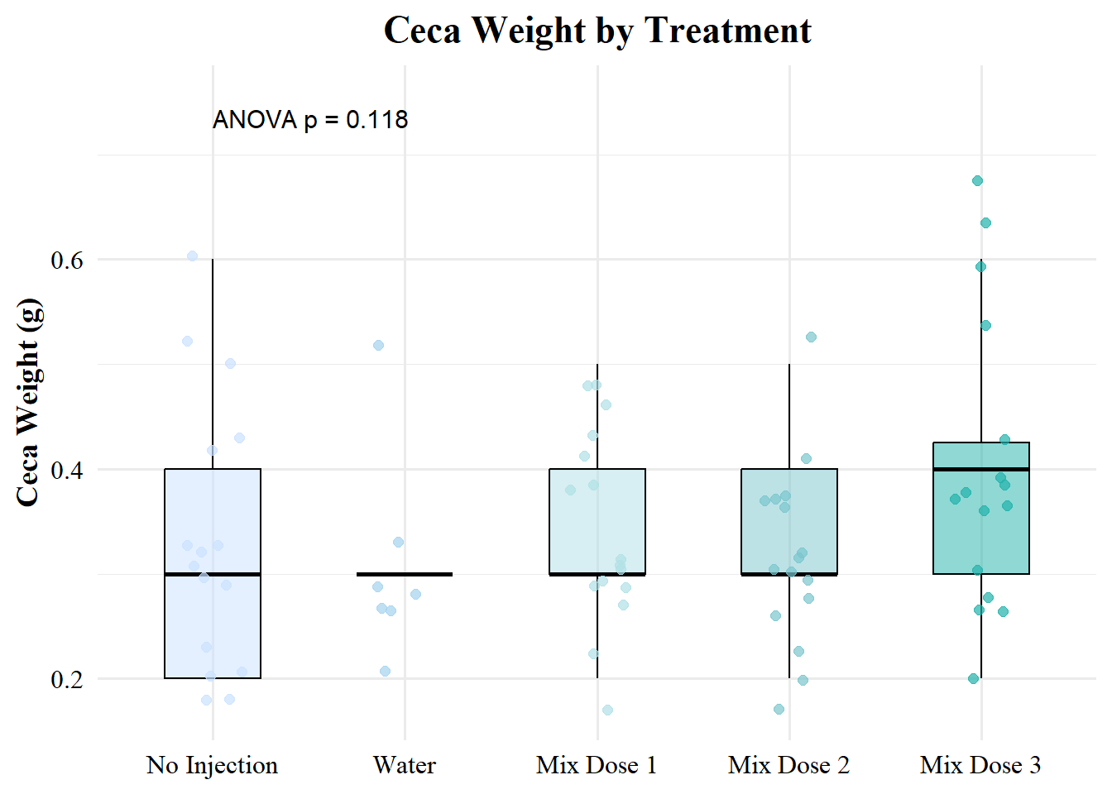
Supplemental Figure 3
INSERT VILLI LENGTH< WIDTH< AND CRYPT DEPTH HERE

